1. **ANALYSIS OF TRANSACTIONS USING ACCOUNTING EQUATION** 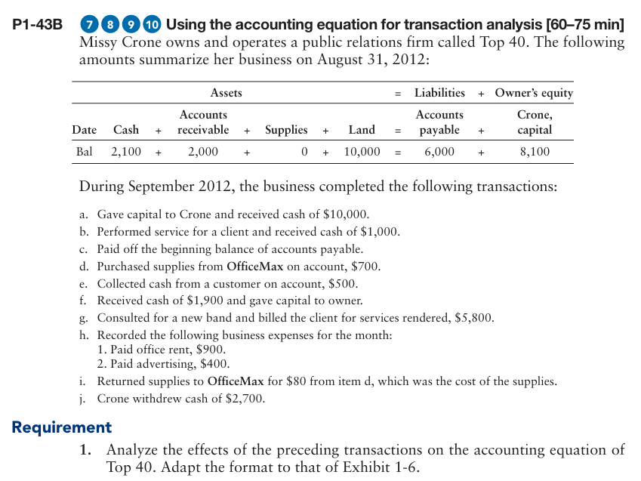
2. **RECORDING TRANSACTIONS, POSTING IN LEDGER AND PREPARING THE TRIAL BALANCE**

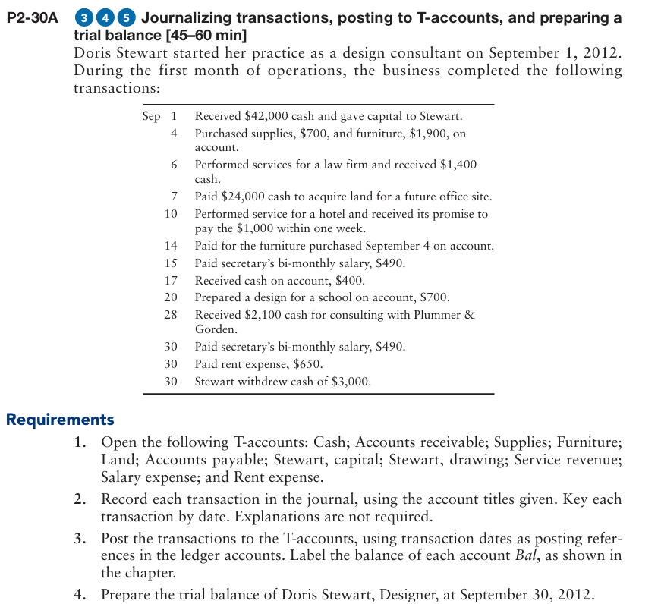

1. **CORRECTING A TRIAL BALANCE WHICH IS NOT BALANCING**

